HOW LONG DOES WASTE TAKE TO DECOMPOSE?
It depends on the type of waste. The remains of fruit and vegetables decompose and become soil in one or two months. The paper takes three months to one year; For other materials, like plastic and glass, they are needed hundreds or even thousands of years. To decompose a glass bottle four thousand years; For a plastic bag one hundred years. Chewing gum is a stubborn waste: it takes five years!
TO DECOMPOSE: the time to transform and absorb waste into the soil. | FRUITS AND VEGETABLES: | PAPER: ____________________
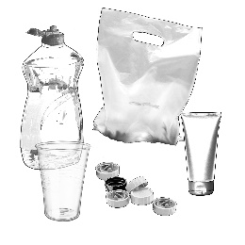  PLASTIC:_____________________ | GLASS:___________________ | CHEWING GUM:_____________________

